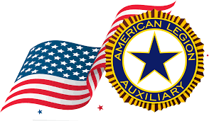

American Legion/Auxiliary
Spring District Meetings 2022
District One: March 19, 2022, at Post Falls Post #143
District Two: March 20, 2022, at Moscow Post #6
District Three: April 23, 2022, at Nampa Post #18
District Four: April 2, 2022, at Mountain Home Post #101
District Five: April 9, 2022, at Eden Post #82
District Six: March 19, 2022, at Malad City Post #65
District Seven: March 12, 2022, at St. Anthony Post #22
District Eight: March 5, 2022, at Challis Post #109
District Nine: March 16, 2022, at Payette Post #33

March Meetings 2022
District Eight: March 5, 2022, at Challis Post #109
District Seven: March 12, 2022, at St. Anthony Post #22
District One: March 19, 2022, at Post Falls Post #143
District Six: March 19, 2022, at Malad City Post #65
District Two: March 20, 2022, at Moscow Post #6

April Meetings 2022
District Four: April 2, 2022, at Mountain Home Post #101
Distict Five: April 9, 2022, at Eden Post #82
District Nine: March 16, 2022, at Payette Post #33
District Three: April 23, 2022, at Nampa Post #18

